
Interim Semester: 2024-25
CSE 2006 - Programming in Java
NAME:SHIVARAMAN T
REG NO:23BAC10009
JAVA LAB PROGRAMS
Unit-1
- Write a Java program for all the operators (Arithmetic, Assignment, Relational, Logical, Unary and Bitwise Operators) to get the values at run time.
ANS-

import java.util.Scanner;

public class OperatorDemo {
public static void main(String[] args) {
Scanner scanner = new Scanner(System.in);
System.out.print("Enter first number (a): ");
int a = scanner.nextInt()
System.out.print("Enter second number (b): ");
int b = scanner.nextInt();
// Arithmetic Operators
System.out.println("\nArithmetic Operators:");
System.out.println("a + b = " + (a + b));
System.out.println("a - b = " + (a - b));
System.out.println("a * b = " + (a * b));
System.out.println("a / b = " + (a / b));
System.out.println("a % b = " + (a % b));
// Assignment Operators
System.out.println("\nAssignment Operators:");
int c = a;
System.out.println("c = a, c = " + c);
c += b;
System.out.println("c += b, c = " + c);
c -= b;
System.out.println("c -= b, c = " + c);
c *= b;
System.out.println("c *= b, c = " + c);
c /= b;
System.out.println("c /= b, c = " + c);
c %= b;
System.out.println("c %= b, c = " + c);
// Relational Operators
System.out.println("\nRelational Operators:");
System.out.println("a == b: " + (a == b));
System.out.println("a != b: " + (a != b));
System.out.println("a > b: " + (a > b));
System.out.println("a < b: " + (a < b));
System.out.println("a >= b: " + (a >= b));
System.out.println("a <= b: " + (a <= b));
// Logical Operators
System.out.println("\nLogical Operators:");
System.out.println("(a > b) && (a > 0): " + ((a > b) && (a > 0)));
System.out.println("(a > b) || (b > 0): " + ((a > b) || (b > 0)));
System.out.println("!(a > b): " + !(a > b));
// Unary Operators
System.out.println("\nUnary Operators:");
System.out.println("a = " + a);
System.out.println("++a = " + (++a));
System.out.println("--a = " + (--a));
System.out.println("b = " + b);
System.out.println("b++ = " + (b++));
System.out.println("After b++, b = " + b);
System.out.println("b-- = " + (b--));
System.out.println("After b--, b = " + b);
// Bitwise Operators
System.out.println("\nBitwise Operators:");
System.out.println("a & b: " + (a & b));
System.out.println("a | b: " + (a | b));
System.out.println("a ^ b: " + (a ^ b));
System.out.println("~a: " + (~a));
System.out.println("a << 2: " + (a << 2));
System.out.println("a >> 2: " + (a >> 2));
scanner.close();
}
}
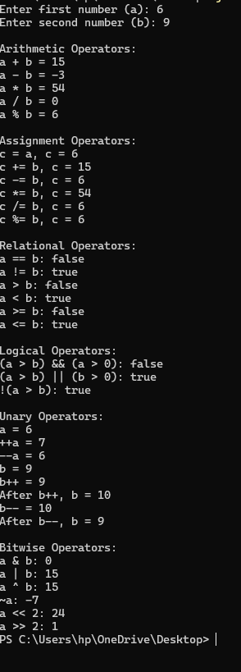

OUTPUT

- Write a following Java program using Flow control statements to get the value at run time.
- Given year is Leap year or not.
- Given number is odd or even.
- Biggest of N numbers.
- Palindrome or not.
- Factorial of a given number.
- Prime Number or not.
- Find the Armstrong Number.
- Fibonacci series of a given count.
- Find the student grade calculation with Grade A, B, C and Fail.
- Display given multiplication table.
- How to Generate Random Number in Java
ANS-
import java.util.Scanner;
import java.util.Random;
public class MultipleTasks {
// Check if the year is a leap year
public static void checkLeapYear() {
Scanner scanner = new Scanner(System.in);
System.out.print("Enter a year: ");
int year = scanner.nextInt();
if ((year % 4 == 0 && year % 100 != 0) || (year % 400 == 0)) {
System.out.println(year + " is a leap year.");
} else {
System.out.println(year + " is not a leap year.");
}
}

// Check if a number is odd or even
public static void checkOddEven() {
Scanner scanner = new Scanner(System.in);
System.out.print("Enter a number: ");
int number = scanner.nextInt();
if (number % 2 == 0) {
System.out.println(number + " is an even number.");
} else {
System.out.println(number + " is an odd number.");
}
}
// Find the biggest of N numbers
public static void findBiggestOfN() {
Scanner scanner = new Scanner(System.in);
System.out.print("Enter the number of elements: ");
int n = scanner.nextInt();
int max = Integer.MIN_VALUE;
System.out.println("Enter the numbers:");
for (int i = 0; i < n; i++) {
int num = scanner.nextInt();
if (num > max) {
max = num;
}
}
System.out.println("The biggest number is: " + max);
}
// Check if a number is a palindrome
public static void checkPalindrome() {
Scanner scanner = new Scanner(System.in);
System.out.print("Enter a number: ");
int number = scanner.nextInt();
int original = number;
int reverse = 0;
while (number != 0) {
int digit = number % 10;
reverse = reverse * 10 + digit;
number /= 10;
}
if (original == reverse) {
System.out.println(original + " is a palindrome.");
} else {
System.out.println(original + " is not a palindrome.");
}
}
// Find the factorial of a number
public static void findFactorial() {
Scanner scanner = new Scanner(System.in);
System.out.print("Enter a number: ");
int number = scanner.nextInt();
int factorial = 1;
for (int i = 1; i <= number; i++) {
factorial *= i;
}
System.out.println("The factorial of " + number + " is: " + factorial);
}
// Check if a number is prime
public static void checkPrime() {
Scanner scanner = new Scanner(System.in);
System.out.print("Enter a number: ");
int number = scanner.nextInt();
boolean isPrime = true;
if (number <= 1) {
isPrime = false;
} else {
for (int i = 2; i <= Math.sqrt(number); i++) {
if (number % i == 0) {
isPrime = false;
break;
}
}
}
if (isPrime) {
System.out.println(number + " is a prime number.");
} else {
System.out.println(number + " is not a prime number.");
}
}
// Check if a number is an Armstrong number
public static void checkArmstrong() {
Scanner scanner = new Scanner(System.in);
System.out.print("Enter a number: ");
int number = scanner.nextInt();
int original = number;
int sum = 0;
while (number != 0) {
int digit = number % 10;
sum += Math.pow(digit, 3); // For 3-digit numbers
number /= 10;
}
if (sum == original) {
System.out.println(original + " is an Armstrong number.");
} else {
System.out.println(original + " is not an Armstrong number.");
}
}
// Generate Fibonacci series up to the given count
public static void fibonacciSeries() {
Scanner scanner = new Scanner(System.in);
System.out.print("Enter the count for Fibonacci series: ");
int count = scanner.nextInt();
int n1 = 0, n2 = 1, n3;
System.out.print("Fibonacci series: " + n1 + " " + n2);
for (int i = 2; i < count; i++) {
n3 = n1 + n2;
System.out.print(" " + n3);
n1 = n2;
n2 = n3;
}
System.out.println();
}
// Calculate student grade based on marks
public static void calculateGrade() {
Scanner scanner = new Scanner(System.in);
System.out.print("Enter the marks: ");
int marks = scanner.nextInt();

if (marks >= 85) {
System.out.println("Grade: A");
} else if (marks >= 70) {
System.out.println("Grade: B");
} else if (marks >= 50) {
System.out.println("Grade: C");
} else {
System.out.println("Grade: Fail");
}
}
// Display multiplication table of a given number
public static void displayMultiplicationTable() {
Scanner scanner = new Scanner(System.in);
System.out.print("Enter a number to display its multiplication table: ");
int number = scanner.nextInt();
for (int i = 1; i <= 10; i++) {
System.out.println(number + " * " + i + " = " + (number * i));
}
}
// Generate a random number
public static void generateRandomNumber() {
Random random = new Random();
int randomNumber = random.nextInt(100); // Generate random number between 0-99
System.out.println("Random number: " + randomNumber);
}
// Main method to provide a menu-driven system for tasks
public static void main(String[] args) {
Scanner scanner = new Scanner(System.in);
int choice;
do {
System.out.println("\nMenu:");
System.out.println("1. Check Leap Year");
System.out.println("2. Check Odd or Even");
System.out.println("3. Find Biggest of N Numbers");
System.out.println("4. Check Palindrome");
System.out.println("5. Find Factorial");
System.out.println("6. Check Prime Number");
System.out.println("7. Check Armstrong Number");
System.out.println("8. Generate Fibonacci Series");
System.out.println("9. Student Grade Calculation");
System.out.println("10. Display Multiplication Table");
System.out.println("11. Generate Random Number");
System.out.println("0. Exit");
System.out.print("Choose an option: ");
choice = scanner.nextInt();

switch (choice) {
case 1:
checkLeapYear();
break;
case 2:
checkOddEven();
break;
case 3:
findBiggestOfN();
break;
case 4:
checkPalindrome();
break;
case 5:
findFactorial();
break;
case 6:
checkPrime();
break;
case 7:
checkArmstrong();
break;
case 8:
fibonacciSeries();
break;
case 9:
calculateGrade();
break;
case 10:
displayMultiplicationTable();
break;
case 11:
generateRandomNumber();
break;
case 0:
System.out.println("Exiting...");
break;
default:
System.out.println("Invalid choice. Please try again.");
}
} while (choice != 0);
scanner.close();
}
}

OUTPUT
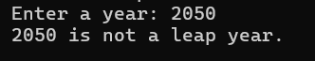
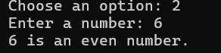
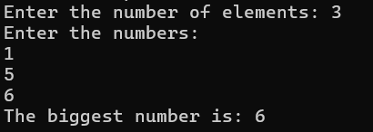
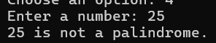
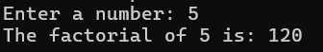
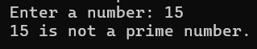
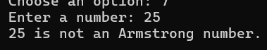
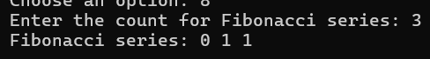
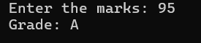
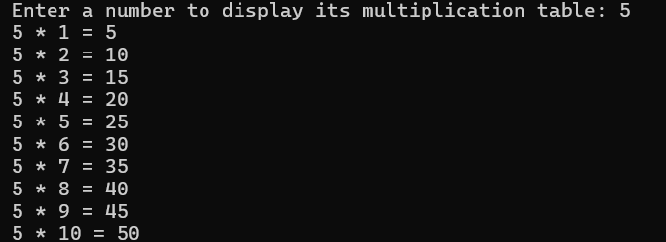
- Reverse a number using while loop
ANS-
import java.util.Scanner;

public class ReverseNumber {
public static void main(String[] args) {
Scanner scanner = new Scanner(System.in);
// Input: Get the number from the user
System.out.print("Enter a number: ");
int number = scanner.nextInt();
int reversedNumber = 0;
int remainder;
// Logic to reverse the number using while loop
while (number != 0) {
remainder = number % 10; // Get the last digit
reversedNumber = reversedNumber * 10 + remainder; // Build the reversed number
number = number / 10; // Remove the last digit from the original number
}
// Output the reversed number
System.out.println("Reversed number: " + reversedNumber);
scanner.close();
}
}
OUTPUT
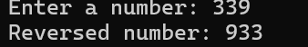
- Java Program to convert Number to Word
ANS-
import java.util.Scanner;
public class NumberToWord {
// Arrays to store words for numbers
private static final String[] units = {
"", "One", "Two", "Three", "Four", "Five", "Six", "Seven", "Eight", "Nine", "Ten",
"Eleven", "Twelve", "Thirteen", "Fourteen", "Fifteen", "Sixteen", "Seventeen", "Eighteen", "Nineteen"
};
private static final String[] tens = {
"", "", "Twenty", "Thirty", "Forty", "Fifty", "Sixty", "Seventy", "Eighty", "Ninety"
};
// Function to convert number to words
public static String convertToWords(int num) {
if (num == 0) {
return "Zero";
}
if (num < 0) {
return "Minus " + convertToWords(-num);
}
String words = "";
if (num / 1000 > 0) {
words += convertToWords(num / 1000) + " Thousand ";
num %= 1000;
}
if (num / 100 > 0) {
words += convertToWords(num / 100) + " Hundred ";
num %= 100;
}
if (num > 0) {
if (num < 20) {
words += units[num];
} else {
words += tens[num / 10];
if (num % 10 > 0) {
words += " " + units[num % 10];
}
}
}
return words.trim();
}

public static void main(String[] args) {
Scanner scanner = new Scanner(System.in);
// Input: Get the number from the user
System.out.print("Enter a number (0-9999): ");
int number = scanner.nextInt();
// Convert the number to words
String word = convertToWords(number);
// Output the result
System.out.println("Number in words: " + word);
scanner.close();
}
}
OUTPUT

- Java Program to Display Alternate Prime Numbers
ANS-
import java.util.Scanner;
public class AlternatePrimeNumbers {
// Function to check if a number is prime
public static boolean isPrime(int num) {
if (num <= 1) {
return false;
}
for (int i = 2; i <= Math.sqrt(num); i++) {
if (num % i == 0) {
return false;
}
}
return true;
}
// Main method to display alternate prime numbers
public static void main(String[] args) {
Scanner scanner = new Scanner(System.in);
// Input: Get the range from the user
System.out.print("Enter the upper limit: ");
int limit = scanner.nextInt();
// Variable to track alternate primes
boolean display = true;

System.out.println("Alternate prime numbers up to " + limit + ":");
// Loop through the range to find prime numbers
for (int i = 2; i <= limit; i++) {
if (isPrime(i)) {
// Display every alternate prime number
if (display) {
System.out.print(i + " ");
}
display = !display; // Toggle the display flag for alternate primes
}
}
scanner.close();
}
}
OUTPUT
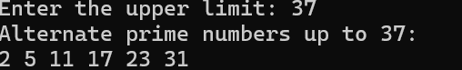

- Java Program to Find Square Root of a Number Without sqrt Method
ANS-
import java.util.Scanner;
public class SquareRoot {
public static void main(String[] args) {
Scanner scanner = new Scanner(System.in);
// Input: Get the number from the user
System.out.print("Enter a number: ");
double number = scanner.nextDouble();
// Calculate the square root using binary search method
double sqrt = findSquareRoot(number);
// Output the square root
System.out.println("The square root of " + number + " is approximately: " + sqrt);
scanner.close();
}
// Function to find the square root using binary search method
public static double findSquareRoot(double num) {
if (num < 0) {
System.out.println("Square root of negative numbers is not real.");
return -1;
}

double precision = 0.00001; // Define the precision level
double start = 0;
double end = num;
double mid = 0;
// Binary search for square root
while ((end - start) > precision) {
mid = (start + end) / 2;
if (mid * mid == num) {
return mid; // Perfect square
} else if (mid * mid < num) {
start = mid;
} else {
end = mid;
}
}
return mid;
}
}
OUTPUT

- Java Program to Swap Two Numbers Using Bitwise Operator
ANS-
import java.util.Scanner;
public class SwapUsingBitwise {
public static void main(String[] args) {
Scanner scanner = new Scanner(System.in);
// Input: Get two numbers from the user
System.out.print("Enter the first number (a): ");
int a = scanner.nextInt();
System.out.print("Enter the second number (b): ");
int b = scanner.nextInt();
// Display original values
System.out.println("Before swapping: a = " + a + ", b = " + b);
// Swapping using XOR
a = a ^ b;
b = a ^ b;
a = a ^ b;

// Display swapped values
System.out.println("After swapping: a = " + a + ", b = " + b);
scanner.close();
}
}
OUTPUT
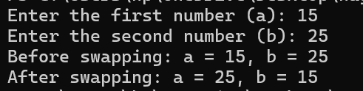
- Java Program to Find GCD of Two Numbers
ANS-
import java.util.Scanner;
public class GCD {
// Function to calculate GCD using Euclidean algorithm
public static int findGCD(int a, int b) {
while (b != 0) {
int temp = b;
b = a % b;
a = temp;
}
return a;
}
public static void main(String[] args) {
Scanner scanner = new Scanner(System.in);
// Input: Get two numbers from the user
System.out.print("Enter the first number: ");
int num1 = scanner.nextInt();
System.out.print("Enter the second number: ");
int num2 = scanner.nextInt();
// Calculate GCD
int gcd = findGCD(num1, num2);
// Output the GCD
System.out.println("The GCD of " + num1 + " and " + num2 + " is: " + gcd);
scanner.close();
}
}

OUTPUT
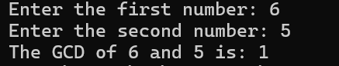

- Java Program to Find Largest of Three Numbers
ANS-
import java.util.Scanner;
public class LargestOfThree {
public static void main(String[] args) {
Scanner scanner = new Scanner(System.in);
// Input: Get three numbers from the user
System.out.print("Enter the first number: ");
int a = scanner.nextInt();
System.out.print("Enter the second number: ");
int b = scanner.nextInt();
System.out.print("Enter the third number: ");
int c = scanner.nextInt();
// Logic to find the largest number using if-else
int largest;
if (a >= b && a >= c) {
largest = a;
} else if (b >= a && b >= c) {
largest = b;
} else {
largest = c;
}
// Output the largest number
System.out.println("The largest number is: " + largest);
scanner.close();
}
}
OUTPUT
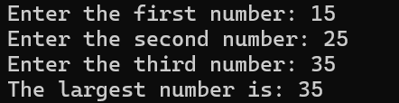

- Java Program to Find Smallest of Three Numbers Using Ternary Operator
ANS-
import java.util.Scanner;
public class SmallestOfThree {
public static void main(String[] args) {
Scanner scanner = new Scanner(System.in);
// Input: Get three numbers from the user
System.out.print("Enter the first number: ");
int a = scanner.nextInt();
System.out.print("Enter the second number: ");
int b = scanner.nextInt();
System.out.print("Enter the third number: ");
int c = scanner.nextInt();
// Using ternary operator to find the smallest number
int smallest = (a < b) ? ((a < c) ? a : c) : ((b < c) ? b : c);
// Output the smallest number
System.out.println("The smallest number is: " + smallest);
scanner.close();
}
}
OUTPUT
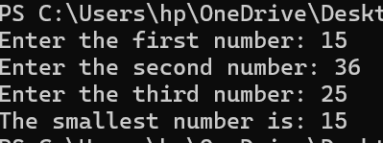

- Java Program to Check if a Number is Positive or Negative
ANS-
import java.util.Scanner;
public class PositiveNegativeCheck {
public static void main(String[] args) {
Scanner scanner = new Scanner(System.in);
// Input: Get the number from the user
System.out.print("Enter a number: ");
double number = scanner.nextDouble();
// Check if the number is positive, negative, or zero
if (number > 0) {
System.out.println(number + " is a positive number.");
} else if (number < 0) {
System.out.println(number + " is a negative number.");
} else {
System.out.println("The number is zero.");
}
scanner.close();
}
}
OUTPUT
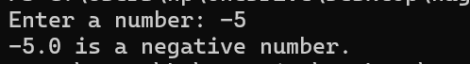

- Java Program to Check if a Given Number is Perfect Square
ANS-
import java.util.Scanner;
public class PerfectSquareCheck {
public static void main(String[] args) {
Scanner scanner = new Scanner(System.in);
// Input: Get the number from the user
System.out.print("Enter a number: ");
int num = scanner.nextInt();
// Calculate the square root of the number
double sqrt = Math.sqrt(num);
// Check if the square root is an integer
if (sqrt == (int) sqrt) {
System.out.println(num + " is a perfect square.");
} else {
System.out.println(num + " is not a perfect square.");
}
scanner.close();
}
}
OUTPUT

- Java Program to Display Even Numbers From 1 to 100
ANS-
public class EvenNumbers {
public static void main(String[] args) {
System.out.println("Even numbers between 1 and 100 are:");
// Loop through numbers from 1 to 100
for (int i = 1; i <= 100; i++) {
// Check if the number is even
if (i % 2 == 0) {
System.out.print(i + " ");
}
}
}
}
OUTPUT
- Java Program to Display Odd Numbers From 1 to 100
ANS-
public class OddNumbers {
public static void main(String[] args) {
System.out.println("Odd numbers between 1 and 100 are:");
// Loop through numbers from 1 to 100
for (int i = 1; i <= 100; i++) {
// Check if the number is odd
if (i % 2 != 0) {
System.out.print(i + " ");
}
}
}
}
OUTPUT

- Java Program to Find Sum of Natural Numbers
ANS-
import java.util.Scanner;
public class SumOfNaturalNumbers {
public static void main(String[] args) {
Scanner scanner = new Scanner(System.in);
// Input: number of natural numbers to sum up
System.out.print("Enter a positive integer: ");
int n = scanner.nextInt();
// Checking if the number is positive
if (n < 1) {
System.out.println("Please enter a positive integer.");
} else {
int sum = 0;
// Loop to calculate the sum
for (int i = 1; i <= n; i++) {
sum += i;
}
// Output the result
System.out.println("The sum of natural numbers up to " + n + " is: " + sum);
}
scanner.close();
}
}
OUTPUT
Last date to complete: 20.09.2024 – 5 PM

